1) Launch one ec2 using Amazon Linux 2 image and add script in user data to install Apache.

=>first create one instanse in ec2 with amazon linux image

=> while creating add script to install apache in discription.

=>then launch instance

=>go to browser and search ip4 address with port 80.

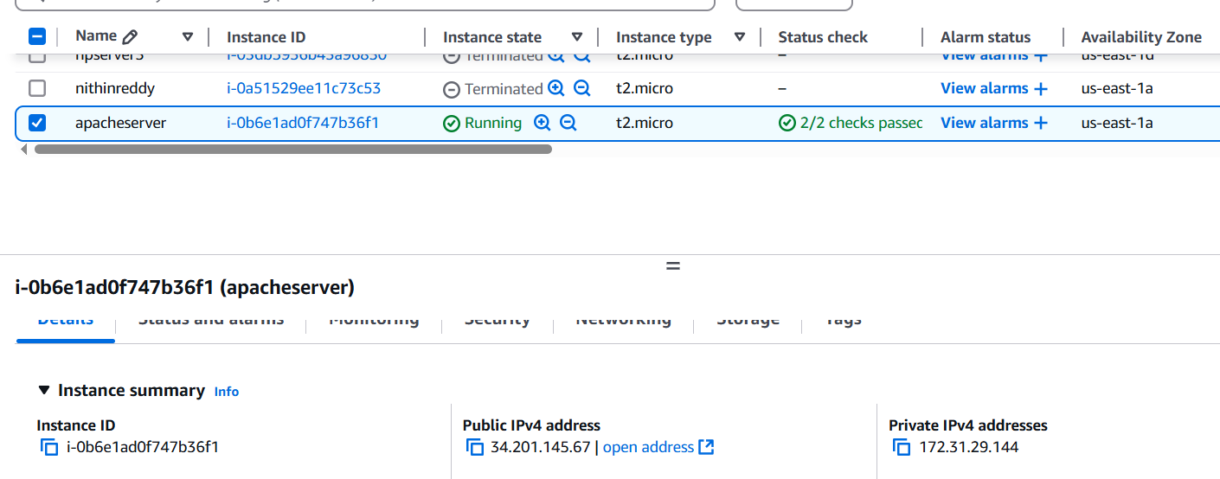

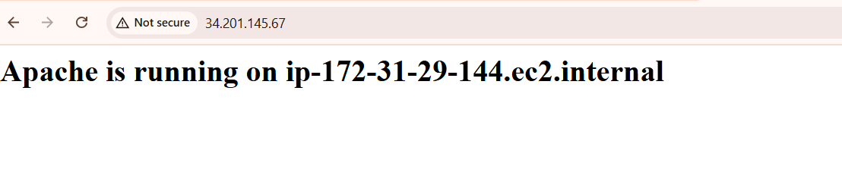

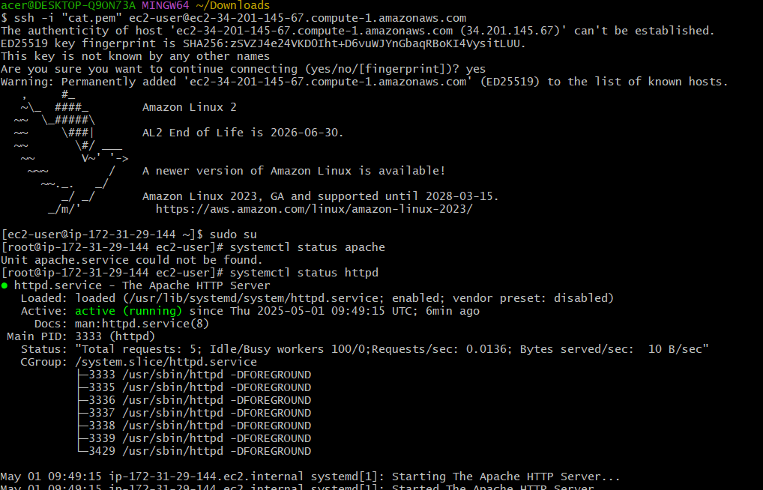

2) Launch one ec2 using Ubuntu image and add script in user data to install Nginx.

=>first create one instanse in ec2 with ubuntu image

=> while creating add script to install nginx in discription.

=>then launch instance.

=>go to browser and search ip4 address with port 80.

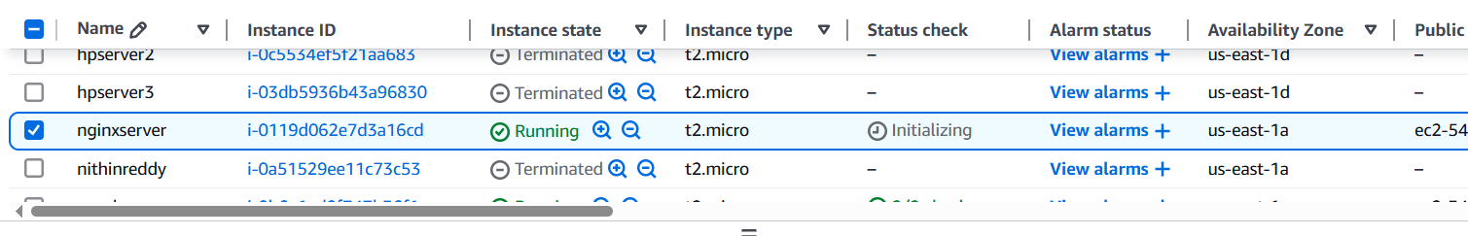

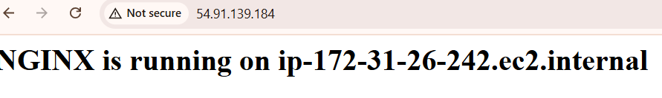

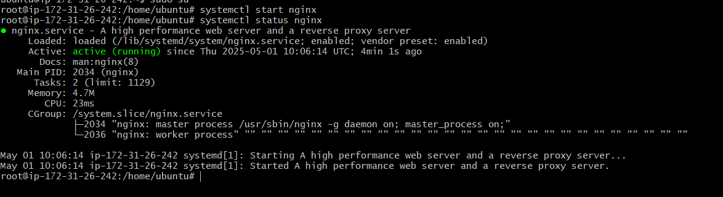

3) Launch one windows server and install tomcat in windows.

● click on launch instance and select Windows   
● select t2.micro or t3.micro(depends on the region)   
● choose a key pair or make a new one   
● select or create a security group to allow the necessary ports, also   
add port 8080 to the inbound rules on aws   
   
● launch instance and download the RDP(remote desktop client) file   
● click on get password, wait for 4 mins, upload your pem key and to   
get the administrator password, use that to login to the windows   
server   
● in the win. server , go to edge and download and install java from   
oracle website then download tomcat from its website and install it   
and run it.

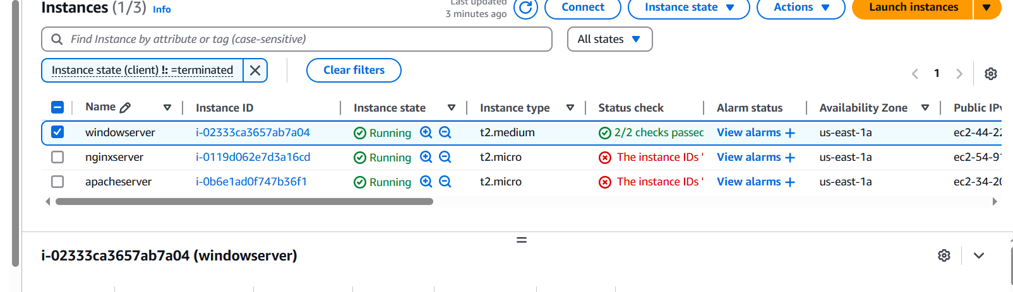

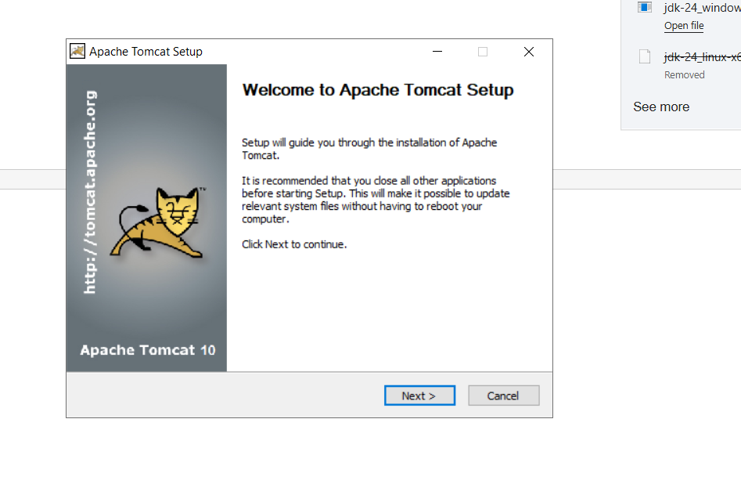

● check if its running by checking the services tab ,also add port 8080   
in the windows firewall settings under inbound rules and it should   
run on the browser inside the remote server and outside too

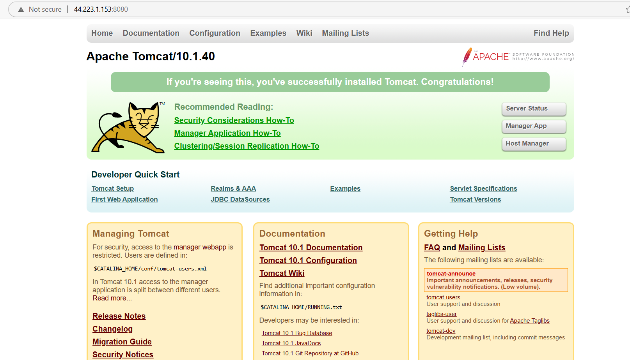

4) Take snapshot of the instane created in Task 1.

* Find the instance you created
* Click the checkbox next to it.
* Scroll down to the **Storage** tab
* Click on the **Volume ID** .This will take you to the **EBS Volumes** page.
  + Click **Actions** > **Create snapshot**
  + **Name**: Enter a name like MyEC2InstanceSnapshot
  + **Description**: (Optional) Add a description
  + Click **Create Snapshot**
* Go to the left-hand menu → **Elastic Block Store** → **Snapshots**
* You should see your new snapshot with **status: completed**

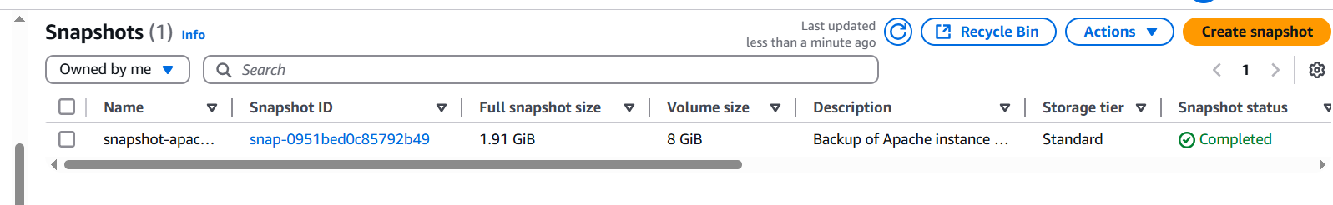

5) Assign password less authentication for ec2 created on Task 2.

● create a public key pair using ssh-keygen on the local system   
● got to its location and copy the public key

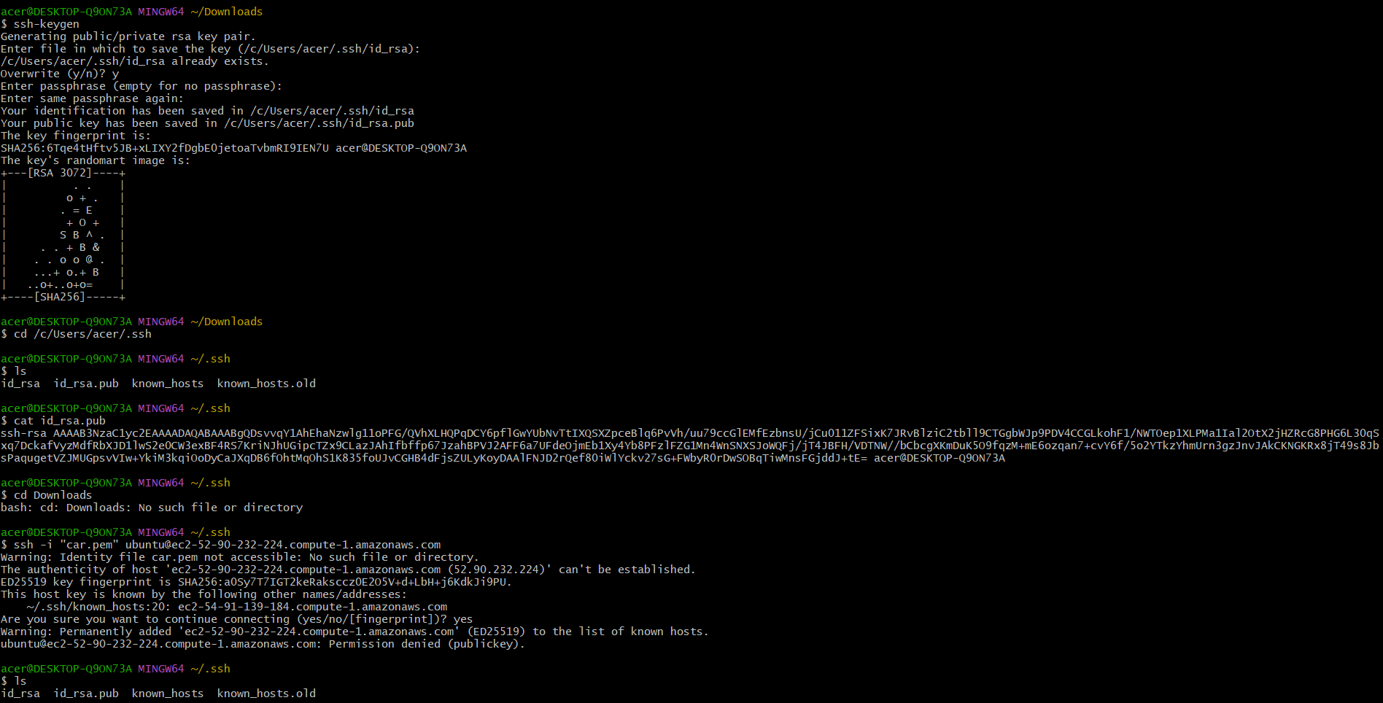

● ssh into the instance and add the public key to the authorized_keys   
on that ec2 instance, save and quit.   
● also change the authorized key permission to 600.   
● exit from the instance and now log in to the instance using local   
machine by ssh ubuntu@<public-ip>   
● If it works without asking for a password or pem key file then we have successfully set up password-less authentication

6) Launch any ec2 using spot purchasing option.

· In the **EC2 Dashboard**, click **“Launch Instance”**

* + **Name**: Enter any name
  + **Application and OS Images (AMI)**: Choose your desired AMI
  + **Instance type**: Choose your desired type
  + **Key pair** : Choose or create a key pair

**Under "Advanced Details"**:

* + Expand the **"Advanced Details"** section.
  + Scroll to **"Purchasing option"**
  + ✅ **Check the box** that says **"Request Spot Instances"**

1. **Configure storage and security group**:
   * Storage: Leave defaults or modify
   * Security group: Use existing or create a new one
2. Click **“Launch Instance”**

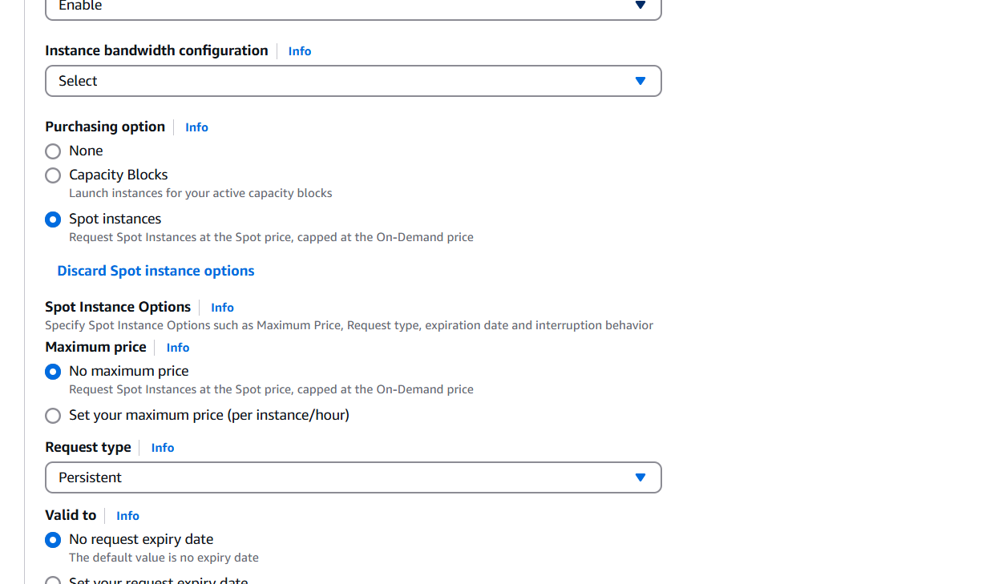

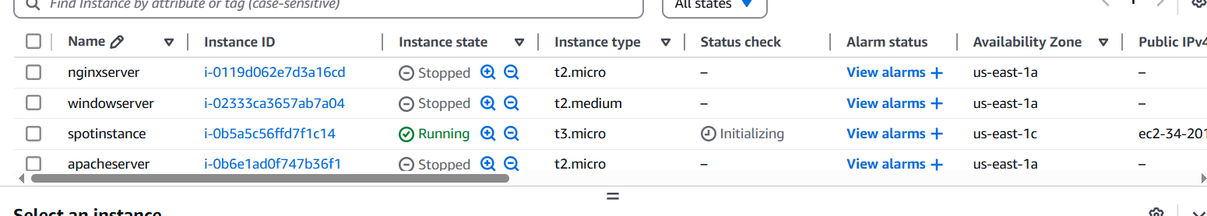

7) Enable Termination policy on ec2 created in Task 2.

=>select the server then click on action.

=>then go to instatnce settings.there we have to click on enable checkbox and save it.

=>then if we try to terminate proccess it will not allow us to terminate.

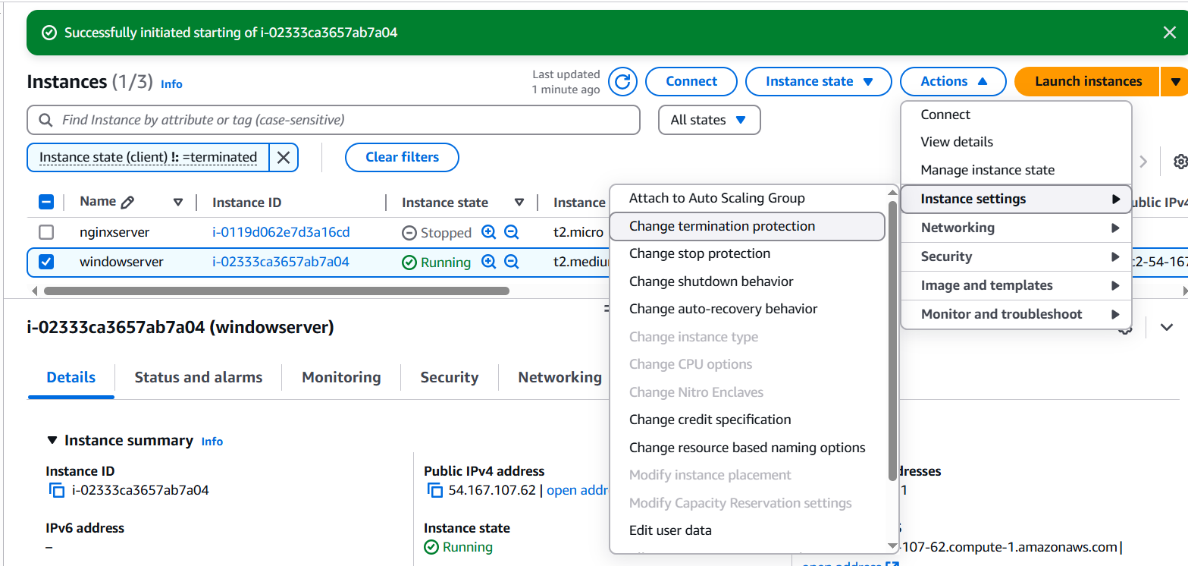

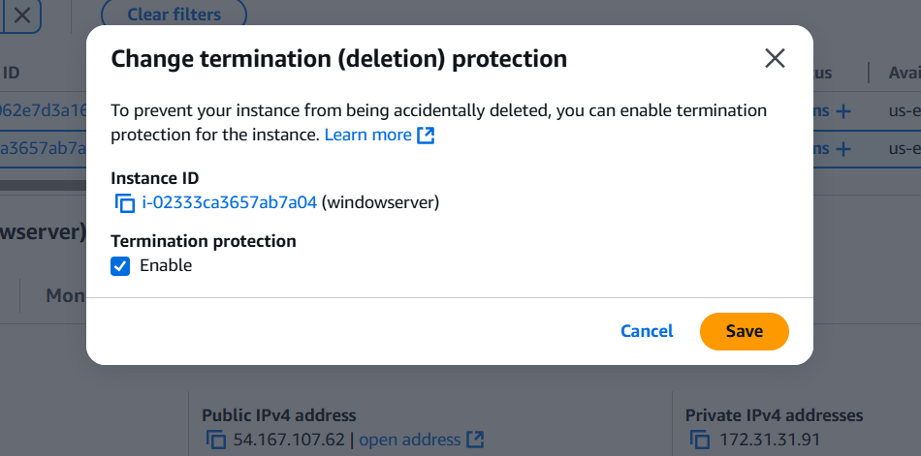

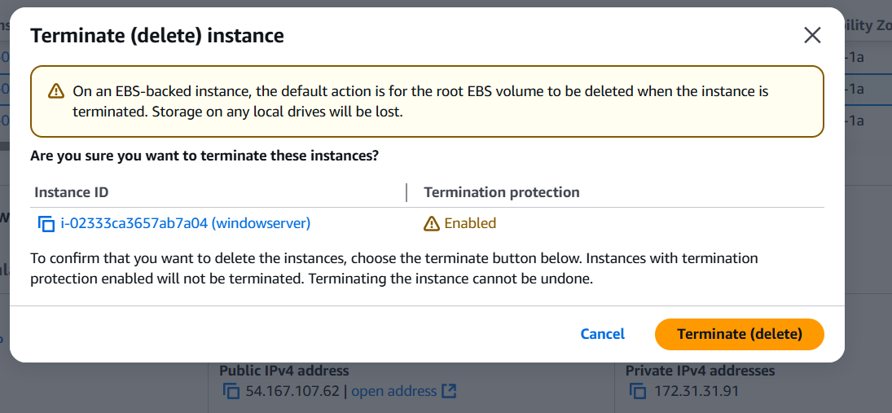

8) Launch one ec2 using Aws CLI.

● Download AWS CLI from their website (windows version) and   
install it   
● Go to you AWS home page and click on your name and select   
security credentials(top right corner)   
● Scrolls down to find the access key section and create one, copy or   
just download the .csv file   
   
   
 ● your aws credentials will be stored in   
C:\users\<username>\.aws\credentials   
● Enter the access key id and the secret key along with the region and   
output format(json/text/table) using the aws configure command

aws ec2 run-instances ^

--image-id ami-0f9de6e2d2f067fca ^

--count 1 ^

--instance-type t2.micro ^

--key-name car ^

--security-group-ids sg-0c506bb94f3de1638 ^

--subnet-id subnet-05f8eb8f486327330 ^

--tag-specifications 'ResourceType=instance,Tags=[{Key=car,Value=MyEC2Instance}]'

● it show should up on the instances webpage too

